SPREADSHEETS
WITH

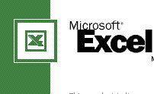

TRAINING NOTES

Table of Contents

Introduction 5
Advantages of a Spread Sheet 5
Disadvantages of a Spread Sheet 5
Microsoft Excel Components and Features 6
Calculating Quickly Excel 8
Selecting cells. 8
Select a cell. 8
Select a Range 8
Select a Noncontiguous Range 9
Working with Worksheets 9
Select a Worksheet 9
Name a Worksheet 9
Insert a worksheet 9
Delete a Worksheet 10
Entering Text and Numbers 10
Enter a Text Label 10
Enter a Number as a Label. 10
Enter a Label from the PickList 11
Enter a Value 11
Editing Cell Contents 11
Naming cells and Ranges 12
Name a Cell or Range 12
Select a Named Cell or Range. 12
Inserting and Deleting Cells 12
Insert One or More Cells 13
Delete One or More Cells 13
Inserting and Deleting Columns or Rows 13
Insert One or More Columns or Rows 13
Delete One or More Columns or Rows 14
Adjusting Column width and Row Height 14
Adjust column Width or Row Height 14
Adjust Column Width or Row Height Using the Mouse. 14
Freezing columns and Rows 15
Unfreeze Columns and Rows 15
Creating a Formula 15
Enter a Formula 15
Copy a formula Using AutoFill 16
Display Formulas 16
Simplifying a Formula with Ranges. 17
Use a Range in a Formula 17
Use a Range Name in a Formula 17
Cell Referencing 17
Cell References in Formulas 17
Understanding Relative and Absolute cell References 18
Relative Cell References 18
Absolute Cell References 19
Calculating with Functions 19
Enter a Function 19
Types of Functions 20
IF Functions 20
IF AND Functions 20
IF OR Function 20
SUM Function 20
AVERAGE Function 21
MAX Function 21
MIN Function 21
SUMIF 21
COUNTIF 22
NESTED FUNCTIONS 22
Using AutoCalculate and AutoFill 22
Calculate a Range Automatically 22
Fill in Data or Formulas Automatically 23
Printing a Worksheet 23
Specify a Print Area 23
Print a worksheet 23
Print Row and Column Titles 24
Add and Print Headers or Footers 24
Previewing Page Breaks 25
Insert a Page Break 25
Preview and Move a Page Break 25
Analyzing Worksheet Data 27
Formatting Text and Numbers 27
Format Text Quickly 27
Format Numbers Quickly. 28
Apply Numeric, Date, and Time Formats. 28
Change Font, font Style, and Font Size 29
Designing conditional Formatting 30
Create Conditions for Formatting 30
Controlling Text Flow and Alignment 30
Control Text Flow 31
Align Data 31
Adding color and Patterns to Cells. 31
Apply color and Patterns. 31
Apply Color Using the Formatting Toolbar. 32
Adding Borders to Cells 32
Apply a Border 32
Creating a Chart 33
Create a Chart using the Chart Wizard 33
Adding and Deleting a Data Series 35
Add a Data Series Quickly 35
Delete a Data Series 36
Change a Data Series 36
Change Data Series Order. 36
Enhancing a Chart 37
Format a Chart Object 37
Change Chart Options 37
Auditing a Worksheet 37
Audit Cells in a Worksheet 38
Understanding Lists 38
Creating a List 38
Create a List 39
Enter Records with a Data Form. 39
Filtering Data in Records 39
Using AutoFilter 39
Applying Data Sub – Totals 41
Filling Cells with Data. 42
Sorting Data in a List 43
Sort Data Quickly 43
Sorting a List Using More Than One Field 44
Protecting Your Data 44
Protect Your Worksheet 44
Protecting a Workbook 45
Share a Workbook 46
Protecting a shared workbook 47
TRACKING CHANGES 47
LINKING WORKBOOKS 48
HIDE AND UNHIDE 48
WORKING WITH MICROSOFT WORD 49
Insert objects created in Excel into a Word document 49
Link data between Microsoft Word and Microsoft Excel. 50
Importing Objects into a spreadsheet. 51

CREATING A WORKSHEET WITH EXCEL

SECTION CONTENTS

Viewing the Excel Window
Selecting Cells
Working with Worksheets
Entering Text and Numbers
Editing Cell Contents
Naming Cells and Ranges
Inserting and Deleting Cells, Columns or Rows
Creating and Simplifying a formula
Understanding Cell References
Calculating with Functions
Using AutoCalculate and AutoFill
Printing a Worksheet
Previewing Page Breaks

Introduction

Are you spending too much time number crunching, rewriting financial reports, drawing charts, or searching for your calculator? Throw away your pencil, graph paper and calculator, and start using Microsoft Excel.

Advantages of a Spread Sheet

- It is much more easier to use computerized spreadsheet such as Excel than to perform manual calculations
- A spreadsheet is a general-purpose tool that can be used to solve a wide variety of problems any information that can be presented as columns and rows.
- Reduces the drudgery of calculations
- Reduces the chances of making error especially computational errors
- Frees user time to concentrate on problem solving
- Allows users to examine alternative solutions.
- Produces quicker results.

Disadvantages of a Spread Sheet

- Incase of a mistake in a value, this affects the whole worksheet
- Wrong formula will lead to incorrect results
- When the sheet is too long it is not possible to view it at ago.

Microsoft Excel Components and Features

A spreadsheet program is and application that manipulates numbers and string data in rows and columns and has the following features:

- Cell – Is an intersection of a row and a column. It is the basic storage in Ms. Excel. It can contain various types of data such as Numeric data (e.g 2005) or Character data (e.g pauline). A cell referenced by its address which consists of the column number and row letter. E.g the first cell is A1, is in the first column A and row 1.
- Worksheet – Are sheets that contain rows and columns forming cells in which the user can enter and store data. They can be referred to as pages in a workbook. They are usually numbers as Sheet1, Sheet2, ….Sheet n. It is made up of 16384 rows and 256 Colulmns.
- Workbook – A workbook is the main file of Ms. Excel program and usually contains a number of worksheets. By default an Ms. Excel workbook must have 16 worksheets. You can navigate to various worksheets by using the sheet tab.
- Workspace – It contains realated workbooks e.g all workbooks that contain data of all the departments of a store.
- Shared workbooks – This is a group of workbook which enable you to use a workbook from any location on the network. Sharing workbooks helps in storing all data in one workbook that can ber referred to easily.
- Linking Worksheets – This Ms. Excel feature enables you to work on a number of worksheets at the same time.
- Charts – This is an Ms. Excel facility used to represent data in form of a graph especially for summary purpose. It enables you to graphically represent data in a worksheet.
- Management of data – This is made possible by using various features like creation of database outlining.
- Range Finder – Uses colored coordinated frames to indicate the cells that are referenced in a given formula if the cell in which the results of the formula is displayed.
- Data Validation – It helps in maintaining consistency in a shared workbook where a number of people use the shared workbook. You can also setup rules and specify a message for a cell or range of cells specifying the kind of data that has to be entered in a cell.
- Track Changes – Allows you to trace changes made to the worksheet by various users in a workbook. This feature is useful when you are working on a shared workbook and want to find our about the modifications made by other users.
- Autocorrect Spellchecker – Automatically corrects common typing, spelling and grammatical errors.
- Page break Management – Automatically prints a worksheet that is larger thatn a page. You can specify which rows and columns are printedon the page by inserting horizontal and vertical page breaks respectively. Excel also provides a page breaks by dragging them to a different location in the worksheet/
- Conditional Formatting – Is a feature that can apply formats to a cell or a range of cells if the condition specified in the cell is true. E.g you can specify that if the value in the cell is 8 then the colour will be green.

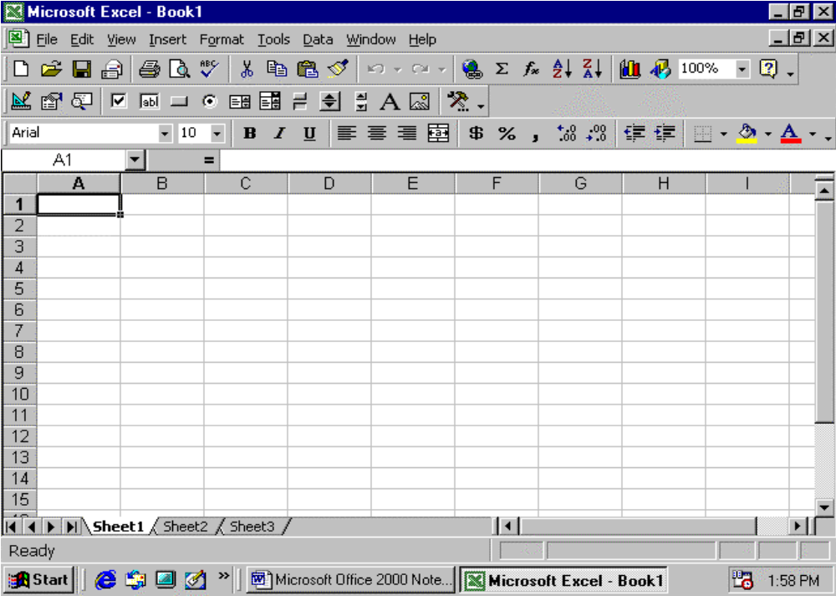

Calculating Quickly Excel

Excel is a spreadsheet program, designed to help you record, analyze and present quantitative information. With Excel you can track and analyze sales, organise finances, create budgets, and accomplish a variety of business tasks in a fraction of the time it would take using pen and paper. With Excel, you can create a variety of documents for analysis and record keeping, such as:

- Monthly sales and expense reports.

- Chart displaying annual sales data

- An inventory of products.

- A payment schedule for an equipment purchase.

The file you create and save in Excel is called a Workbook. It contains a collection of worksheets, which look similar to an accountant’s ledger sheets, but can perform calculations and other tasks automatically.

Selecting cells.

A cell is the intersection of a column and row. You must select a cell and make it active to work with it. A range is one or more selected cells that you can edit, delete, format, print, or use in a formula just like a single cell. The active cell has a dark border; selected cells have a light shading called a see-through selection. A range can be contiguous (all selected cells are adjacent) or noncontiguous (selected cells are not all adjacent). A range reference lists the upper – left cell address, a colon (:), and the Commas separate noncontiguous cells. For example, B4: D10, E7, L24.

Select a cell.

Click a cell to select it.

Select a Range

- Click the first cell you want to include in the range.

- Drag to the last cell you want to include the range. The upper – left cell of a selected range is active and others are highlighted.

Select a Noncontiguous Range

- Click the first cell or select the first contiguous range you want to include.

- Press and hold Ctrl while you click additional cells and select other ranges.

Working with Worksheets

Each new workbook opens with three worksheets (or sheets), in which you store and analyze values. You work in the active, or selected, worksheet. The default worksheet names are Sheet1, Sheet2, and Sheet3, which appear on the sheet tab, like file folder labels. As you create a worksheet, give it a meaningful name to help you remember it contents. The sheet tab size adjusts to fit the name’s length. If you work on a project that requires more than three worksheets, add additional sheets to the workbook so all related information is stored in one file.

Select a Worksheet

- If necessary, click a sheet tab scroll button to display other tabs.

- Click a sheet tab to make it the active worksheet.

- To select multiple worksheets, press and hold Ctrl as you click other sheet tabs.

Name a Worksheet

- Double – click the sheet tab you want to name.

- Type a new name.

- The current name, which is selected, is replaced when you begin typing.

- Press Enter.

Insert a worksheet

- Click the sheet tab to the right of where you want to insert the new sheet.

- Click the Insert menu, and then Click worksheet.

- A new worksheet is inserted to the left of the selected worksheet.

Entering Text and Numbers

Labels turn a worksheet full of numbers into a meaningful report by clarifying the relationship between the numbers. Labels are text or numbers that identify the data on the worksheet columns and rows; for example item or 3-27-200. An apostrophe (‘) before the number label, such as the year 2000, prevents Excel from using that number in any calculations. The PickList, a list of labels you entered previously, helps keep your labels consistent. Values are the numbers you want to use in calculations. You can enter values as whole numbers, decimals, or dates.

Enter a Text Label

- Click the cell where you want to enter a text label.

- Type a label.

A label can include uppercase and lowercase letters, spaces, punctuations, and numbers.

- Click the Enter button on the formula bar, or press Enter.

Enter a Number as a Label.

- Click the cell where you want to enter a number label.

- Type ‘ (apostrophe). The apostrophe is a label prefix and does not appear on the worksheet.

- Type a number.

- Examples of number labels include a year, social security number, or telephone number.

- Click the Enter button on the formula bar, or press Enter or Tab.

Enter a Label from the PickList

- Right – click the cell where you want to enter a label, and then click Pick From List.

- Click an entry from the list.

Enter a Value

- Click the cell where you want to enter a value.

- Type a value.

To simplify your date entry, type the values without commas and dollar signs and apply a numeric format to them later.

- Press enter or click the Enter button on the formula bar.

Editing Cell Contents

No matter how much you plan, you can count on having to make changes on a worksheet. Sometimes you’ll need to correct an error; other times you’ll want to add new information or see the results for different conditions, such as higher sales, fewer produced units, or other variables. You edit data just as easily as you enter it, using the formula bar or directly in the active cell.

Edit Cell Content.

- Double – click the cell you want to edit.

- The status bar displays Edit instead of Ready.

- Use the mouse pointer or the Home, end, and arrow keys to position the insertion pint in the cell.

- To erase characters, press Backspace or Delete.

- To enter characters, type new characters.

- Press Enter or click the Enter button on the formula bar to accept the edit, or click the Cancel button on the formula bar to cancel it.

Naming cells and Ranges

To make working with ranges easier, Excel allows you to name them. The name sales, for example, is easier to remember than the coordinates B47:D10. You can use named ranges in formulas the same way you use cell references and rang addresses. Named ranges can be used to navigate large worksheets.

Name a Cell or Range

- Select the cell or range you want to name.

- Click the name on the formula bar.

- Type a name for the range.

A range name can include uppercase or lowercase letters, numbers, and punctuation, try to use a simple name that reflects the information in the range, such as Sales2000.

- Press Enter. The Name box shows the name whenever you select the range.

Select a Named Cell or Range.

- Click the Name box drop-down arrow on the formula bar.

- Click the name of the cell or range you want to use.

The range name appears in the Name box, and all cells included in the range are highlighted on the worksheet.

Inserting and Deleting Cells

You can insert new, blank cells anywhere on the worksheet, so you can enter new data exactly where you want it. Inserting cells moves the remaining cells in the column or row to the right or down as you choose and adjusts any formulas so they refer to the correct cells, You can also delete cells if you find you don’t need them; deleting cells shifts the remaining cells to the left or up – just the opposite of inserting cells.

Insert One or More Cells

- Select one or more cells where you want to insert new cell(s)

- Click the Insert menu, and then click Cells.

- To move the contents of the cells right, click the Shift Cells Right option button; to move the contents of the cells down, click the Shift Cells Down option button. Either way, two blank cells are inserted.

- Click OK.

Delete One or More Cells

- Select one or more cells you want to delete.

- Click the Edit Menu, and then click Delete.

- To move the remaining cells left, click the Shift Cells Left option button; to move the remaining cells up, click the shift Cells Up option button.

- Click OK.

Inserting and Deleting Columns or Rows

You can insert one or more blank columns and rows on a worksheet between columns or rows that are already filled. The header buttons above each column and to the left of each row indicate the letter or number of the column or row.

Inserted columns are added to the left of the selected columns. Inserted rows are added above the selected row. Excel repositions existing cells to accommodate the new columns and rows and adjusts any existing formulas so that they refer to the correct cells.

Insert One or More Columns or Rows

- To insert a column, click the column header button directly to the right of where you want to insert the new column.

- To insert a row, Click the row header button directly below where you want to insert the new row.

- To insert multiple columns or rows, drag to select the header buttons for the number of columns or rows you want to insert.

- Click the Insert menu, and then click Column or Rows.

Delete One or More Columns or Rows

- Select the columns or rows you want to delete.

- Click the Edit menu, and then click Delete.

Adjusting Column width and Row Height

You’ve entered labels and values, constructed formulas and even formatted the cells only now some of your data isn’t visible. You know it’s there, but you just can’t see it. Also, some larger sized labels are cut off. Narrow or widen each column width to fit its contents and adjust row heights as needed.

Adjust column Width or Row Height

- Click the column or row header button for the firs column or row you want to adjust.

If you want, drag to select more columns or rows.

- Right-click the selected column(s) or row(s), and then click column Width or Row Height.
- Type a new column width or row height in points.

- Click OK.

Adjust Column Width or Row Height Using the Mouse.

Position the mouse pointer on the right edge of the column header button or the bottom edge of the row header button for the column or row you want to change.

When the mouse pointer changes to a double-headed arrow, click and drag the pointer to a new width or height.

Freezing columns and Rows

Once you’ve finished creating the worksheet structure – labels and formulas – you’re ready to enter data. The first six columns and twelve rows or so are just fine, but as you scroll to enter data in later columns or rows, the labels shift out of view. Instead of memorizing the labels, freeze the label columns and row, so they remain visible as you scroll through the rest of the worksheet. You can freeze just a row or a column as well.

Freeze columns and Rows.

- Click the cell that intersects the rows and columns you want to remain visible on screen.

- Click the Window menu, and then click Freeze Panes.

- Edit and scroll the worksheet as usual.

Unfreeze Columns and Rows

- Click the worksheet that you want to unfreeze.

- Click the Windows menu, and then click unfreeze Panes.

Creating a Formula

Instead of manually adding subtracting, multiplying, or dividing, use formulas. A formula is and equation that analyzes values to return a result. All formulas begin with the equal sign(=) followed by arguments – values ( such as 7.2 ) and cell references – connected by arithmetic operators (shown in the table). You enter and edit formulas just as you do labels and values 0 in the formula bar or in the cell. After you create a formula, you can quickly copy it to adjacent cells using AutoFill. Excel displays the formulas’ results in cells, but you can change the view at any time to display the formulas themselves.

Enter a Formula

- Click a cell where you want to enter a formula.

- Type an equal sign (=) to begin the formula. If you do not begin a formula with and equal sign, Excel displays the information you type; it does not perform the calculation.

- Enter the first argument (a number or a cell reference,). If the argument is a cell reference, type the cell reference or click the cell.

If the formula can accept cell references, the cursor changes to a light gray cell-like shape to encourage you to select the cell on the worksheet.

- Enter an arithmetic operator.

- Enter the next argument

- Repeat steps 4 and 5 to complete the formula.

- Click the Enter button on the formula bar, or press Enter.

The cell displays the formula result, and the formula bar displays the formula.

Copy a formula Using AutoFill

- Select the cell that contains the formula you want to copy.

- Point to the fill handle in the lower-right corner of the selected cell (the pointer changes to a black plus sign).

- Drag to select the adjacent cells where you want to paste the formula.

Display Formulas

- Click the Tools menu, and then click Options.

- Click the view tab.

- Click to select the Formulas check box.

- Click OK.

Simplifying a Formula with Ranges.

Simplify your formulas by using ranges and range names. If 12 cells on your worksheet contain monthly budget amounts, and you want to multiply each amount by 10 percent, you can insert one range address in a formula instead of inserting 12 different cell addresses, or you can insert a range name. Using a range name in a formula helps to identify what the formula does; the formula =SALES2000*.10, for example, is more meaningful that =D7:07*.10.

Use a Range in a Formula

- Type an equal sign (=) to begin the formula, and type the first part of the formula if necessary.

- Click the first cell of the range and drag to the last cell in the range, or press and hold Ctrl as you click each cell in the range.

- Complete the formula, and then press Enter.

Use a Range Name in a Formula

- Type an equal sign (=) to begin the formula, and type the first part of the formula if necessary.

- Press F3 to display a list of named ranges.

- Click the name of the range you want to insert.
- Click OK.

- Complete the formula, and then press enter.

Cell Referencing

Cell References in Formulas
A reference is the address of a cell or a range of cells in a worksheet, by using cell referencing you can refer to the data of various cells, in a formula. You can refer to a complete column in a worksheet by referencing it using the reference to the column. If you refer to cells in other workbooks, the referencing is called external referencing.
Depending on the task you perform, excel offers 3 types of cell referencing techniques:
- Relative Referecing – is a reference to the cells in a formula based on the position of the cell that contains the formula. E.g A1
- Absolute Referencing – You can refer to a particular cell in a formula regardless to the position of the cell that contain the formula. If you want to refer to a cell by using absolute referencing, precede the name of the column and row with a ($) sign. E.g =$A$1
- Mixed Referecing is a combination of both Relative and Absolute Referencing e.g =A$1
- 3-D Referencing – Used to refer to the same address of a cell or range of cell in a multiple worksheets in a workbook. A 3-D Reference includes the cell or range reference preceded by a range of worksheet names. E.g = sheet1!A1

Understanding Relative and Absolute cell References

Each cell, the intersection of a column and row on a worksheet, has a unique address, or cell reference, based on its column letter and row number. For example, the cell reference for the intersection of column D and row 4 is D4.

Excel’s power lies in calculating data on a worksheet. To give you the most flexibility in analyzing your data, a formula combines arithmetic operators (+,-,/,*,^) with values and cell references.

The simplest formula refers to a cell. If you want one cell to contain the same value as another cell, type an equal sign followed by the cell reference, such as =D4. The cell that contains the formula is known as a dependent cell because its value depends on the values in changes, the cell that contains the formula also changes. The formula =D4*7 multiplies the value in cell D4 by 7. The formula is recalculated whenever the value in cell D4 changes.

Depending on your task, you can use either relative cell references, which are reference to cells relative to the position of the formula, or absolute references, which are cell references that always refer to cells in a specific location.

Relative Cell References

Using a relative cell reference is like giving a friend directions from their door to a specific destination: Go out your door, Walk downhill three blocks, turn left, and then walk two blocks. Similarly, the cell with the formula is the door, or starting point. The relative cell reference specifies the directions to locate the value. For example, the formula =D4 in cell E5 tells Excel to go up one cell and left one cell from cell E5.

When you copy and paste a formula that uses relative references, the references in the pasted formula change to reflect cells that are in the same relative position to the formula. For example, if you copy the formula =D4 from cell E5 to cell F7, the pasted formula becomes =E6, which, like the original formula, refers to the cell that is one cell above and to the left of the formula.

Absolute Cell References
If you don’t want a cell reference to change when you copy a formula, make it an absolute reference by typing a dollar sign($) before each part of the reference that you don’t want to change. For example, the formula=D4 changes as you copy it from cell to cell, but the formula =$D$4 always references that same cell. You can add a $ before the column letter, that row number, or both. To ensure accuracy and simplify updates, enter constant values (such as tax rates, hourly rates, and so on) in a cell, and then use absolute references to them in formulas.

Calculating with Functions
Functions are preset formulas that save you the time and trouble of creating commonly used equations. Excel includes hundreds of functions that you can use alone or with other formulas or functions. Functions perform a variety of tasks from adding, averaging, and counting to more complex tasks, such as calculating monthly loan payments.

Enter a Function
- Click the cell where you want to enter the function.
- Type an equal sign(=), type the name of the function, and then type (, and opening parenthesis. For example, to insert the AVERAGE function, type =AVERAGE).
- Type the argument or click the cell or range you want to insert in the function.
- Click the Enter button on the formula bar, or press Enter. Excel adds the closing parenthesis to complete the function.

Types of Functions

IF Functions
The IF function is used for testing values and formulas. It takes certain values that are called arguments. These are:
- Logical test – is an expression that evaluates to either TRUE or FALSE.
- Value if true – is the value that is returned if logical test evaluates to TRUE. It can be another formula.
- Value if false – is the value that is returned if logical test evaluates to FALSE. It can be another formula.
The general format of using if statements is:
=if(Argument/Condition, Value if true, Value if false)

IF AND Functions
The IF AND function takes a list of arguments and returns TRUE if all the arguments are TRUE and FALSE if one or more of the arguments is FALSE. You can specify a maximum of 30 arguments.
The general format of using AND statement is:
=AND(Argument 1, Argument 2, ………..Argument k) where K is less than or equal to 30.

IF OR Function
The IF OR function returns TRUE if any of the specified arguments is TRUE and FALSE if all the arguments are FALSE. You can specify a maximum of 30 arguments.

SUM Function
Adds all the numbers in the defined range of cells values or constants. The general format (syntax) of using this function is:
=SUM(Number1,Number2………..NumberN)
Number1, Number2,………..NumberN, are 1 to 30 for which you want the total value or sum.

AVERAGE Function
Returns the arithmetic mean of values specified in the range of cells. The arguments to this function must be numbers or references to a range of cells. If an array or reference argument contains text or empty cells, these values are ignored but cells with a value of zero are included. This means that it is important to determine the number of cells that have zero while using the AVERAGE function. The general format (syntax) of using this function is:
=AVERAGE(Number1,Number2,……..NumberN)
Number1, Number2, ……………. NumberN, are 1 to 30 for which you want the average.
Note
When averaging cells, keep in mind the difference between empty cells and those containing the value zero, especially if you have cleared the zero values check box on the view tab (Options command, Tools menu). Empty cells are not counted, but zero values are.

MAX Function
Returns the highest value in the selected range of cells. If an argument is in array or reference, only numbers in the array or reference are used. Empty cells or text in the array or references are ignored. If the arguments contain no numbers, the MAX function returns a zero value.

MIN Function
This is similar to the MAX function and returns the smallest number in the selected range of cells.

SUMIF
This function is used to calculate the sum of a given range of cells if the condition/argument given is TRUE.
N/B: IF stands for the condition, which can be either TRUE or FALSE.

COUNTIF
This function is used to count the number of occurrences/times a value appears in a selected range of cells if the stated condition is TRUE.
N/B: IF stands for the condition, which can be either TRUE or FALSE.

NESTED FUNCTIONS
In certain cases, you may need to use a function as one of the arguments of another function. For example, in the function below, the formula uses a nested AVERAGE function and compares the result with the value 50.
=IF(AVERAGE(F2:F5)>50,SUM(G2:G5),0)

Using AutoCalculate and AutoFill
Sometimes you want to see the results of a calculation but don’t want to add a formula to the worksheet. AutoCalculate displays in the status bar the sum, average, maximum, minimum, or count of selected cells. This result doesn’t print, but provides quick answers while you work. Another shortcut is AutoFill, which enters data based on the adjacent cells. Use the fill handle to extend data in series (such as dates), and copy values or formulas to adjacent cells. When you enter new data to a list, Excel applies the same formulas and formatting data as in the preceding cell.

Calculate a Range Automatically
- Select the range (contiguous or noncontiguous). The sum of the selected cells appears in the status bar.
- To change the type of calculation, right click the AutoCalculate button on the status bar.
- Click the type of calculation you want.

Fill in Data or Formulas Automatically
- Select the first cell in the range you want to fill, enter the starting value for a series or a formula to copy, and then press Enter.
- Right Click as you drag the fill handle of the selected cell (the pointer changes to a black plus sign) over the range.
- Release the mouse button, and then click the type of series you want.

Printing a Worksheet
At some point you’ll want to print your work so you can distribute it to others or use it for other purposes. You can print all or part – a print area – of any worksheet and control the page appearance. You can determine whether to print the gridlines, column letters, and row numbers that appear on the screen, or whether to repeat certain columns and rows on each page.

Specify a Print Area
- Select the range you want to print.
- Click the File menu, point to Print Area, and then click Set Print Area.
- A dotted line indicates that area you set.

Print a worksheet
- Click the file Menu, and then click Print.
- If necessary, click the Name drop-down arrow, and then click the printer you want to use.
- Select whether you want to print the entire document or only the pages you specify.
- Select whether you want to print the selected text or objects, the selected worksheets, or all the worksheets in the workbook with data.
- Click Ok.

Print Row and Column Titles
- Click the File menu, and click Page Setup.
- Click the Sheet tab.
- Enter the row numbers and column letters that you want to contain the titles, or click the appropriate Collapse Dialog Box button, select the title rows or columns, and then click the Expand Dialog box button.
- Click Ok.

Add and Print Headers or Footers
- Click the File menu, click Page Setup, and then click the Header/Footer tab.
- Click Custom Header or Custom Footer.
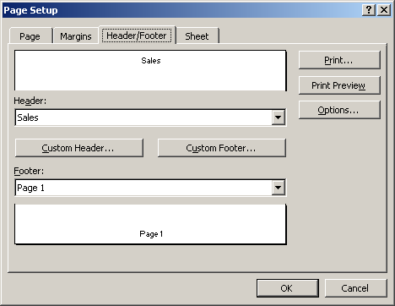
- Enter text, or insert the page number, date, time, filename, or table name in the Left centre, or Right section.
- Click OK.
- Click OK or Print.

Previewing Page Breaks
If you want to print a worksheet that is larger than one page, Excel divides it into pages by inserting automatic page breaks. These page breaks are based on paper size, margin settings, and scaling options you set. You can change which rows or columns are printed on the page by inserting horizontal or vertical page breaks. In page break preview, you can view the page breaks and move them by dragging them to a different location on the worksheet.

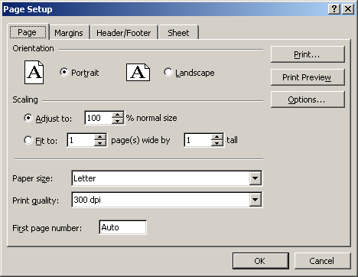

Insert a Page Break
- To insert a horizontal page break, click the column header button to the right of where you want to insert a page break.
- To insert a vertical page break, click the row header button below where you want to insert a page break.
- To start a new page, click the cell below and to the right of where you want a new page.
- Click the Insert menu and then click Page Break.

Preview and Move a Page Break
- Click the View menu, and click Page Break Preview.
- Page breaks appear as a thick blue line.
- Drag a page break to a new location.
- When you’re done, click the View menu, and then click Normal.

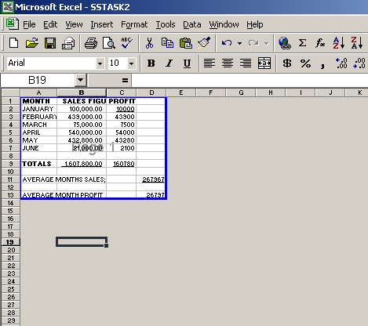

SECTION CONTENTS
Formatting Text and Numbers
Controlling Text Flow and Alignment
Adding Color, Patterns, and Borders to Cells
Creating a Chart
Adding and Deleting a Data Series
Enhancing a Chart
Auditing a Worksheet
Understanding Lists
Creating a List
Filtering Data In Records
Subtotals
Sorting Data in List
Analyzing and Charting Data Using a PivotTable
Modifying a PivotTable and PivotChart
Tracking Data changes
Protecting Your Data.
In addition to using a worksheet to calculate values, you can also use it to manage a list of information, sometimes called a database. You can use an Microsoft Excel worksheet to keep an inventory list, a school grade book, or a customer database. Excel provides a variety of tools that make it easy to keep lists up-to-date and analyze them to get the information you want quickly. For example, you can use these tools to find out how many inventory items are out of stock, which students are earning an A average, or which product is the best selling item.

Analyzing Worksheet Data
Excel’s date analysis tools include alphanumeric organizing (called sorting), displaying information the meets specific criteria (called filtering), and summarizing data within a table (called a PivotChart). You can analyze data directly on a worksheet, or use a feature called a Data form, an on screen data entry tool similar to a paper form. A data form lets you quickly enter data by filling in blank text boxes, and then it adds the information to your database, also called a list. This tool makes entering information in a lengthy list a snap!

Formatting Text and Numbers
Sometimes you want to format cells with labels differently from cells with totals, You can change the appearance of data in selected cells without changing its actual label or value. Format text and numbers by using font attributes, such as boldface, italics, or underlines, to enhance data to catch the readers, eye and focus their attention. You can also apply numeric formats to values to better reflect the type of information they present dollar amounts, dates, decimals, percentages. For example, you can format a number to display up to 15 decimal places or none at all.

Format Text Quickly
- Select a cell or range with the text you want to format.
- Click one of the buttons on the Formatting toolbar to apply that attribute to the selected range.
- Bold
- Italic
- Underline
- Click the font or Font size drop-down arrow, and then select a font or size.
You can apply multiple attributes to the range.

Format Numbers Quickly.
- Select a cell or range with the numbers to format.
- Click one of the buttons on the formatting toolbar to apply that attribute to the selected range.
- Currency Style
- Percent Style
- Comma Style
- Increase Decimal
- Decrease Decimal
You can apply multiple attributes to the range.

Apply Numeric, Date, and Time Formats.
- Select a cell or range with the numbers to format.
- Click the Format menu, and then click cells.
- Click a Number tab.
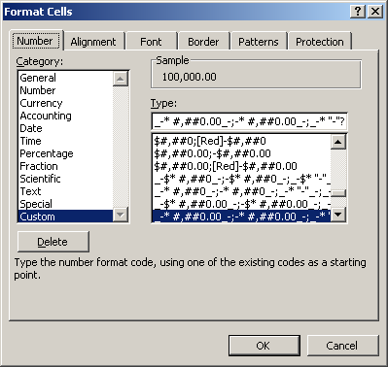
- Click a numeric, date, or time category.
- Select the formatting options you want to apply.
- Preview the selections.
- Click Ok.

Change Font, font Style, and Font Size
- Select the cell or range containing the font to change.
- Click the Format menu, and then click Cells.
- Click the Font tab.
- Select a font.
- Select a font style
- Select a font size.
- Select any additional formatting effects.
- Click Ok.

Designing conditional Formatting
Make your worksheets more powerful by setting up conditional formatting, which lets you determine a cell’s formatting based on its contents. For example, you might format this year’s sales information in red italics if it’s lower than last years sales but in green bold if it’s higher. Apply the first format directly to the cell. Then set up the second format to occur if the condition is true, The condition can be based on a cell value or a formula. Each worksheet cell can have as many as three conditions.

Create Conditions for Formatting
- Select the cell or arrange to format conditionally.
- Click the Format menu, and then click conditional Formatting.
- Select whether you want to test a cell value or formula.
- For cell value, select a comparison operator.
- Enter a value or formula for the condition. For the Between or Not Between operator, enter both an upper and lower cell value or range.
- Click format, Select the format for when the condition is true, and then click Ok
- Preview the results.
- To add another condition, click Add and then repeat step 3 through 7. You can set up to three conditions per cell.
- Click OK

Controlling Text Flow and Alignment
A label might not always fit within its column width. If the cell to the right is empty, a label spills into it, but if that cell contains data, the label is truncated (or cut off). Rather than widen the column, you can wrap the text to multiple lines, shrink the text to edit the cell, merge cells, or angle the text orientation by degrees. When you enter data in a cell, labels align on the left edge of the cell and values and formulas align on the right edge. The placement of data relative to the left and right edge of a cell is called horizontal alignment, and the placement relative to the top and bottom is called vertical alignment. For example, the label 2000 Division 1 Sales can be stacked 3 lines in a column as wide as Division 1.

Control Text Flow
- Select a cell or range with the text you want to reflow.
- Click the Format menu, click Cells, and then click the Alignment tab.
- Click an orientation point by which to angle the text.
- Click to select check boxes
- Wrap Text forces text to form multiple lines in the cell.
- Shrink To Fit reduces font size to fit text in the cell.
- Merge Cells combines selected cells into one.
- Click OK.

Align Data
- Select a cell or range with data you want to align.
- Click an alignment button on the Formatting toolbar.

Adding color and Patterns to Cells.
Colors and Patterns added to the worksheet’s light gray grid help identify data and streamline entering and reading data. If your data spans many columns and rows, color every other row light yellow to help readers follow the data. Or add a red dot pattern to cells with totals. Color adds background shading to a cell. Patterns add dots or lines to a cell in any color you choose.

Apply color and Patterns.
- Select a cell or range to which you want to apply colors and patterns.
- Click the Format menu, and then click Cells.
- Click the Patterns tab.
- To add shading to the cell, click a color in the palette.
- To add a pattern to the cell, click the Pattern drop-down arrow, and then click a pattern and color in the palette.
- Click OK

Apply Color Using the Formatting Toolbar.
- Select a cell or range.
- Click the Fill Color drop-down arrow on the formatting toolbar.
- If necessary, click the More Buttons drop-down arrow to display the button.
- Click a color.

Adding Borders to Cells
The light gray grid that appears on the worksheet helps your eyes move from cell to cell. Although you can print these gridlines, sometimes a different grid pattern better emphasizes your data. For example, you might put a decorative line border around the title, a double-line bottom border below cells with totals, or a thick border between sections of a complicated worksheet. You can add borders of varying colors and widths to any or all sides of a single cell or range.

Apply a Border
- Select a cell or range to which you want to apply borders, or click the Select All button to select the entire worksheet.
- Click the Format menu, and then click cells.
- Click the Border tab.
- Select a line style
- Click the Color drop-down arrow, and then click a color fir the border.
- If you want a border on the outside of a cell or range, click Outline. If you want a border between cells, click Inside. If you want to remove a border, click None.
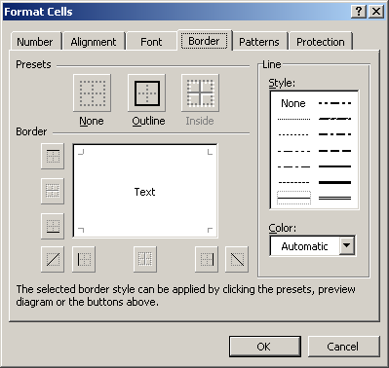

- To set a custom border, click a Border button or click the Preview Border box where you want to add a border.
- Click OK.

Creating a Chart
A chart provides a visual graphical representation of numerical data. Whether you turn numbers into a bar, line, pie, surface, or bubble chart, patterns become more apparent. For example, the trend of annual rising profits becomes powerful in a line chart. A second line showing diminishing annual expenses creates an instant map of your business’s success. Titles on the chart, horizontal or x-axis, and vertical or Y axis, identify the data. A legend connects the colors and patterns in a chart with the data they represent. Gridlines are horizontal and vertical lines to help the reader determine data values in a chart. Excel simplifies the chart-making process with the Chart Wizard, a series of dialog boxes that leads you through all the steps to create an effective chart on a new or an existing worksheet.

Create a Chart using the Chart Wizard
- Select the data range you want to chart.
Make sure you include the data you want to chart and the column and row labels in the range. The Chart Wizard expects to find this information and incorporates it in your chart.
- Click the Chart Wizard button on the Standard toolbar.
- Click a chart type.
- Click a chart sub-type.
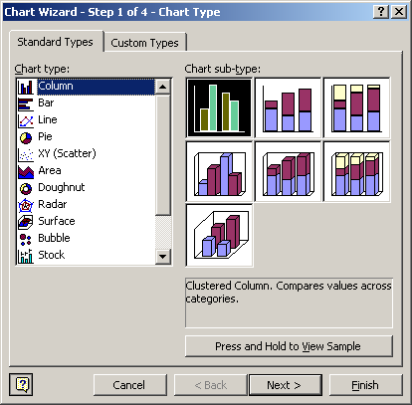
- Click the Click And Hold To View Sample button to preview your selection.
- Click Next.
- Verify the data range.
- Select to plot the data series in rows or in columns.
- Click Next to continue.
- Select chart options.
- Title tab: Type titles for the chart, x-axis, and y-axis in the appropriate text boxes.
- Gridlines tab: Select the type of gridlines you want for the x-axis and y-axis.
- Legend tab: Click to select the Show Legend check box, and then select its location.
- Preview the options.
- Click Next to continue.
- Select to place the chart on a new or existing sheer.
- A chart placed on an existing sheet is an embedded object.
- Click finish.
- Drag the chart to a new location if necessary.
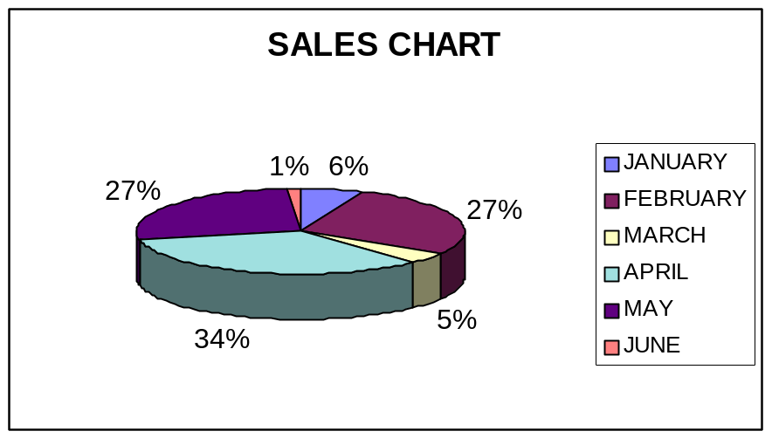

Adding and Deleting a Data Series
Each range of data that comprises a bar, column, or pie slice is called a data series; each value in a data series is called a data point. You define the data series when you select a range and then open the Chart Wizard. But what if you want to add a data series to an existing chart? Add a data series by changing the data range information in the Chart Wizard, by using the Chart menu, or by dragging a new data series into an existing chart. You can delete a data series just as quickly as you add one.

Add a Data Series Quickly
- Select the range that contains the data series you want to add to your chart.
- Drag the range into the existing chart.
- Release the mouse button to display the chart with the added data series.

Delete a Data Series
- Select the chart that contains the data series you want to delete.
- Click any data point in the data series.
- The series is selected in the chart and the worksheet.
- Press Delete.
- Excel removes the data series and displays the revised chart.

Change a Data Series
- Select the chart that contains the data series you want to change.
- Click the Chart menu and the click Source Data.
- Click the Series tab.
- Click the series name you want to change.
- Click the Name or Values Collapse Dialog button to change the name or value, and then Click the Expand Dialog button.
- Click OK.

Change Data Series Order.
- Select the chart that contains the data series you want to delete.
- Double – click any data point in the data series.
- Click the Series Order tab.
- Click the series you want to reorder.
- Click Move Up or Move Down.
- Click OK.

Enhancing a Chart
You can format or change any chart object-such as titles legends, gridlines, data labels, data tables, and text annotations – to enhance the appearance of the chart and increase its overall effectiveness. A chart title identifies it purpose and axis titles identify the plotted data. Titles can be multiple lines and formatted like other worksheet text.

Format a Chart Object
- Double –click the chart element you want to format.
- Click the tab that corresponds to the type of change you want to make.
- Select the formatting options you want to change or apply.
- Click OK.

Change Chart Options
- Select a chart you want to change.
- Click the Chart menu, and then click Chart Options.
- Click the chart option tab (Titles, Axis, Gridlines, Legend, Data Labels, or Data Table) you want to change.
- Enter information and select the options you want.
- Click Ok.

Auditing a Worksheet
When you create formulas on a worksheet, Excel can give visual cues to show the relationship between cells in the formula. With the Auditing toolbar, you can examine the relationship between cells and formulas on your worksheet and identify errors. When you use the auditing tools, tracer arrows point out cells that provide data to formulas and the cells that contain formulas that refer to the cells. A box is drawn around cell ranges that provide data to formulas.

Audit Cells in a Worksheet
- Click the cell you want to audit.
- Click the Tools menu, point to Auditing, and the click Show Auditing Toolbar.
- To find cells that provide data to a formula, select the cell that contains that formula, and then click the Trace Dependents button.
- If a formula displays and error value, such as #DIV/0!, click the Trace Error button to locate the problem.
- To remove arrows, click the Remove Precedent Arrows button, Remove Dependent Arrows button, or Remove All Arrows button.
- Click the Close button on the Auditing toolbar.

Understanding Lists
A database is a collection of related records. Examples of databases are an address book, a list of customers or products, and a telephone directory. In Excel, a database is referred to as list.

Creating a List
To create a list in Excel, you can enter data on worksheet cells, just as you do any other worksheet data, but the placement of the field names and list range must follow these rules.
- Enter field names in a single row that is the first row in the list.
- Enter each record in a single row.
- Do not include any blank rows within the list range.
- Do not use more than one worksheet for a single list range.
You can enter data directly in the list or in a data form, a dialog box in which you can view, changes, add, or delete records in a list. Don’t worry about entering records in any particular order; Excel tools organise an existing list alphabetically, by date, or in almost any order you can imagine.

Create a List
- Open a blank worksheet, or use a worksheet that has enough empty columns and row for your list.
- Enter a label for each field in adjacent columns across the first row of the list.
- Enter field information for each record in its own row; start wit the row directly below the field names.

Enter Records with a Data Form.
- Enter a label for each field in adjacent columns across the first row of the list.
- Click the Data menu, and then click Form.
- Click OK to set the row as the column labels.
- Enter information for each field, pressing Tab to move from one field to the next.
- Click New and enter field information for each additional record.
- When you’re done, click Close

Filtering Data in Records
Filter allows you to display only those rows that meet a specified criterion. You can also filter without sorting a list.

Using AutoFilter
To Filter using autofilter feature:
- Select any cell in the list
- Choose Data Menu
- Select the AutoFilter option from the filter submenu. Drop down controls are placed at the top of each column

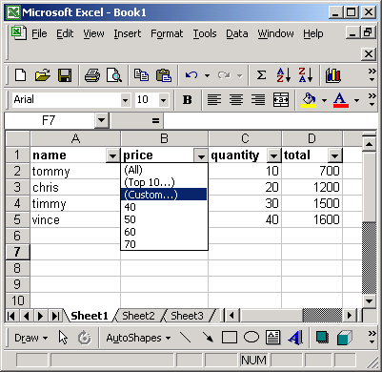
- Click on a drop down control to select the criterion on which the list has to be filtered
- Select one of the options out of the three:
  - All – Displays all rows that fallwithin the upper or lower limits that you specify.
  - Top 10 - Displays all rows that fall within the upper or lower limits that you specify.
  - Custom – Applies two criteria values within the current column.
To filter a list by using the custom option:
- Place the pointer anywhere on the worksheet
- Select data menu
- Choose Autofilter from the filter submenu
- Choose the custom option in the drop-down list of a column
- Specify your filter conditions in the resulting dialogue box
- Click Ok to filter the list
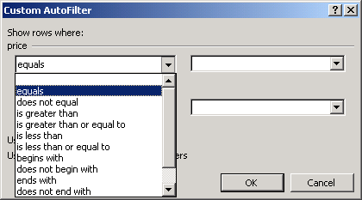

Applying Data Sub – Totals
To add sub – totals to a list:
- Sort the list of data according to your requirement
- Select a cell in the list
- From data menu select sub – totals option and it’s resulting dialogue box appears
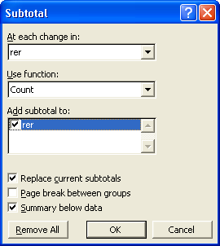
The sub – totals dialogue has the following options:
- At each change – Enables you to specify the column that contains the items or groups by which you want to subtotal the values in other columns.
- Use function – Enables you to select the summary function has to be used to subtotal the values.
- Add subtotal – Enables you to select one or more options to specify the columns that contain the values that have to be subtotaled.
- Replace the current subtotals – Enables you to replace the all subtotals in the list if there are any, with the new subtotals. You have to deselect the option if you do not want to replace the existing subtotals.
- Page break between groups – Enables you to insert the subtotal and grand totals rows below the detail data.
- Make you adjustments
- Click OK.

Filling Cells with Data.
Auto fill feature:
Displays an auto fill handle, i.e. a plus sign handle at the bottom right corner of the active cell. You can drag the handle to fill the series.
Or
You can use edit menu to perform the same task
- Enter the first value and select the range to be filled
- From Edit menu select Series option from the Fill submenu. The series dialogue box appears

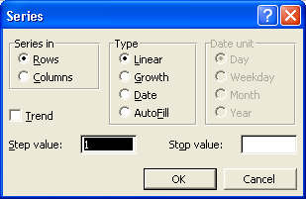
- Indicate whether you want to fill your series in rows or columns by selecting any one of the following options:
- Select the Auto fill option and type area
- Click OK to create the series.

Sorting Data in a List
After you enter records in a list, you can reorganize the information by sorting the records. For example, you might want to sort record in a client list alphabetically by last name or numerically by their last invoice date. Ascending order lists records from A to Z, latest to earliest or lowest to highest. Descending order list record from Z to A, latest to earliest, or highest to lowest. You can sort the entire list or use AutoFilter to select the part of the list you want to display in the column. You can sort a list based on one or more sort fields, fields you select to sort the list. A simple sort, for example, might organise a telephone directory alphabetically by last name; a more complex sort might organise the telephone directory numerically by area code and then alphabetically by last name.

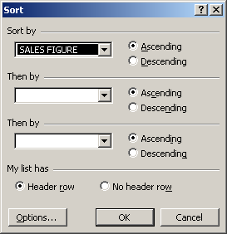

Sort Data Quickly
- Click the field name by which you want to sort.
- Click the Sort Ascending or the Sort Descending button on the Standard toolbar.

Sorting a List Using More Than One Field
- Click anywhere within the list range.
- Click the Data menu, and then click Sort.
- Click the Sort By drop-down arrow, and then click the field on which the sort is based (the primary sort field)
- Click the Ascending or Descending option button.
- Click the top Then By drop-down arrow, select a second sort field, and then click Ascending or descending.
- If necessary, click the lower Then By drop-down arrow, select a third sort field, and then click Ascending or Descending.
- Click the Header Row option button to exclude the field names (in the first row) from the sort, or click the No Header Row option button to include the field names (in the first row) in the sort. Click OK.

Protecting Your Data
You work very hard creating and entering information in a workbook. To preserve all your work – particularly if others use your files – you can password protect its contents. You can protect a sheet or an entire workbook. In each case, you’ll be asked to supply a password, and then enter it again when you want to work on the file.

Protect Your Worksheet
- Click the Tools menu, point to Protection, and then click Protect Sheet.
You can protect an individual worksheet, the entire workbook, or you can protect and share a workbook. The steps for all are similar.
- Click to select the check boxes fir the options you want to protect.
- Type a password.
A password can contain any combination of letters, numbers, spaces, and symbols. Excel passwords are case-sensitive so you must type uppercase ns lowercase letters correctly when you enter passwords.
- Click Ok.
- Retype the password.
- Click OK.
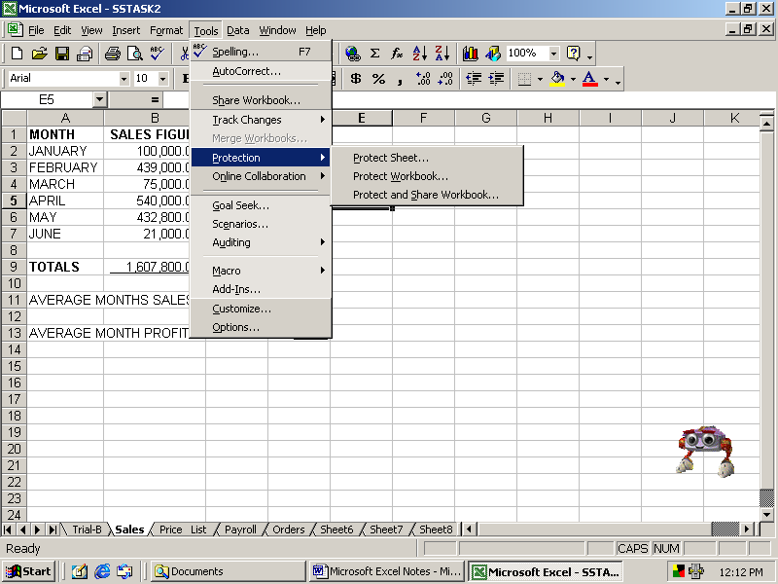

Protecting a Workbook
- Select the Protect Workbook option from the protection submenu on the tools menu, the protect workbook dialog box is displayed.
- The protect workbook has two areas, protect workbook for and password option. The protect workbook area has two options:
  - Structure – protects the structure of a workbook so that worksheets cannot be deleted, moved, hidden, unhidden, or renamed. By using this option, new sheets cannot be inserted in workbook. This option is selected by default.
  - Windows – protects the window of the workbook from being moved, resized, hidden, unhidden, or closed. The password (optional) area contains a field in which you can type a password to prevent unauthorized user from removing workbook protection.
    - Make the required selections and type a password
    - Type the password again to confirm it
    - Click OK
SHARING A WORKBOOK

Share a Workbook
A workbook can be shared in a Networked system. To enable several users in a networked system to share a workbook.
- Select share workbook option on the Tools menu, the share workbook dialog box appears.
The editing tab contains two options:
- Allow changes by more than one user at the same time – enables multiple users to edit the workbook at the same time.
- Who has this workbook open now – displays the names of all the users who are working on the workbook currently.
The advanced tab has four areas:
- Track change area has the following options:
  - Keep change history for - maintains information about the changes made to the workbook based on elapsed time. You can enter the number of days you want to maintain the history of the workbook by specifying the number of days in the days option.
  - Don’t keep change history – turns off the change history feature
- Update changes area has the following options:
  - When file is saved – displays the changes made and saved by other users whenever you save the workbook
  - Automatically every – updates changes made by other users at the interval that you specify in the minutes option
- Conflicting changes between users has the following options:
  - Ask me which changes win – enables you to choose which changes to restore when two or more users edit the same cell
  - The changes being saved win – replaces any changes made to a cell with your changes each time you save the workbook.
- Include in personal view area that in turn has the following options:
  - Print settings – saves personal print settings that you might have specified in the shared workbook
  - Filter settings – saves any filter settings that you made to the workbook
- Click OK after making the required selections.
- Click OK to confirm to share the workbook is shared. You have to save the shared workbook in a shared folder so that other users on the network can access the shared workbook.
N/B: You can also protect a shared workbook.

Protecting a shared workbook
- Select the protect shared workbook option from the protection sub menu on the tools menu. The protect workbook dialog box displayed.
The protect shared workbook dialog box contains two areas, protect workbook for and password (Optional). The protect workbook for area contains an option called sharing with track changes. If this option is selected, the history tracking option is enabled in the shared workbook. The history tracking option is disabled unless the protection password is provided.
This option enables you share and protect a workbook automatically if the workbook is not shared.
When sharing with track changes option is selected, the password (optional) area gets activated and you are prompted to enter a password and confirm it
- Click OK to protect the shared workbook.

TRACKING CHANGES
The track changes feature helps you to find out the changes made by various users in a shared workbook. To track changes n Ms Excel:
- Select Tools menu.
- Select Highlight Changes Option from the Track Changes. The highlight changes dialog box appears.
- Adjust the track changes option e.g. changes from when, changes made by who had changes made at where.
- Click OK to apply the selections made.
- You can also choose to select or reject the changes made by you or other users working on the worksheet. To select or reject changes in a worksheet.
- Select Accept or Reject option from the track changes sub menu on the tools menu. The select changes to accept or reject dialog box appears.
- Click OK to apply the selections made.

LINKING WORKBOOKS
- Open the workbooks to link and activate the source workbook.
- Select the cell that has to be linked to the new workbook from the source workbook.
- Copy the contents of the cell by selecting the copy command on the Edit menu.
- Select the cell in the new workbook in which you want to paste the contents.
- Select the Paste Special option on the Edit Menu. The paste special dialog box is displayed.
- Click on the Paste link button, e.g. All, Values, Comments, e.t.c.

HIDE AND UNHIDE
The steps to hide columns and rows in Excel are:
- Select the columns/rows that have to be hidden.
- Choose Format menu.
- Select column/row option.
- Choose Hide command.
The steps to unhide columns and rows in Excel are:
- Select the columns/rows adjacent to the hidden columns/rows/
- Choose Format menu.
- Select column/row option.
- Choose Unhide command.

WORKING WITH MICROSOFT WORD
There are times when you need to create memos, letters or reports, and often you will need to refer to your Microsoft Excel data in these documents.
For example, if you are creating a report or a memo in Microsoft Word, you might want to insert data from a Microsoft Excel worksheet such as a budget or personnel report information.
With Microsoft Excel and Microsoft Word you can be able to create such ‘combination’ documents easily.
Microsoft Excel and Microsoft Word have similar menus, toolbars, and operations, so you do not need to learn a new interface when you switch between programs.

Insert objects created in Excel into a Word document
- In order to produce well-formatted reports using some of the information produced by the spreadsheets and the word processor.
- Windows offers several facilities for sharing information between applications.
Definitions
- The application from which the information is being copied from is known as the source application.
- The host or client is the application to which the information is being copied.
- The information being shared or copied is known as an object. This could be a range or a chart from a spreadsheet, a block of text from a word-processor or a drawing from a graphics package.
Step by step
- In the source application, select the object you want to copy, then select Cut or Copy from the Edit menu (or use the equivalent icon). This places the object in the clipboard and makes it available to other applications.
- Switch to the client application and select Paste from the Edit menu. This will insert the object at the insertion point.
- To edit (change) the values in the pasted copy, you have to get back into the source file, make the changes, copy the changed object to the Clipboard and then replace the pasted copy.
Example
- Suppose you copy an Excel spreadsheet and paste it into a Word document. The result will be a table in the Word document.
- This table will retain some of the formats from the Excel spreadsheet i.e. bold, italics, alignments and colours.
The table will also lose all the formulae and will simply contain the results, as they were when the table was copied.
- To edit (change) the values in the pasted copy, you have to get back into Excel, open the source file, make the changes, copy the changed range to the clipboard and then replace the table in the word document.

Link data between Microsoft Word and Microsoft Excel.
- With Word and Excel, you can link information from one to the other. This technique addresses the problem of updating the copied object every time the source changes.
- When you use it, the copy is linked with the source application and file such that any changes made in the source file are immediately updated in the copy. This way, you are always sure that the copied object is the same as the original.
- This linking allows you to make changes (edit) to the copy from either within the source or the host. Changes made from within source will be reproduced in the host document.
- Those documents made from within the host will not be reflected in the source. These will be lost every time the copy is updated from the source. This feature allows one to modify the copy without affecting the source and always be in a position to easily revert back to the original. This comes in very handy when you may wish to use some advanced formatting features available in the host for producing a more effective report.
Step by Step
- To create a link between a range in Excel file and a Word document, copy the range into the clipboard and then select Paste Special in the Edit menu of word.
- Selecting Paste Special will display the dialog box from which you select Paste link.
- Select Microsoft Excel Worksheet Object and then click on the OK button.
- The worksheet will be pasted as a picture, but you can edit it by double-clicking on it. If you double click on it, Excel will start automatically and the worksheet file will open.
Any changes you make in the worksheet will be reflected in the word document.
Example
- If you need to produce some reports containing different versions of the same spreadsheets data (say income projections using different parameters), you would link the spreadsheet file with the word processor document.
- You would then get into the spreadsheet, change the data and then print a copy of he word for each of the different parameters (versions).

Importing Objects into a spreadsheet.
If you want to put a copy of a graphic e.g. pictures or logos into a Microsoft Excel spreadsheet, you do not need to link it. You can simply copy and paste, or use the picture command on the Insert menu to place the picture on your sheet.
The graphic will not retain any links to its original application; it will simply become an object like the text boxes or charts etc.
- Position the cell pointer where you would like the object to be inserted.
- From the Insert menu select Picture and then click on From file.
- Open the folder in which the object is stored.
- Select the file to be inserted and click on Insert button.
- Resize the object if necessary.

